Customer Churn Prediction System Using Machine Learning

1. Title Page
Project Title: Customer Churn Prediction System Using Machine Learning
Student Name: Fatimah Ramzan
Project Type: Machine Learning / Data Science Project
Deployment Platform: PythonAnywhere
Programming Language: Python

2. Abstract
Customer churn is an important problem for businesses because losing existing customers can negatively affect revenue and long-term growth. This project develops a machine learning-based Customer Churn Prediction System that predicts whether a customer is likely to leave a service.
The project follows a complete data science workflow, including business understanding, SQL analysis, exploratory data analysis, feature engineering, preprocessing, machine learning model development, model evaluation, explainability, web application development, and deployment.
The final machine learning model achieved an accuracy of 80.27%, with a precision of 66.55%, recall of 51.60%, and F1 score of 58.13%. A Flask-based web application was developed to allow users to enter customer information and receive a churn prediction along with the probability of churn.
The final application was deployed online using PythonAnywhere and can be accessed through the project deployment link.

3. Introduction
Customer retention is an important goal for many businesses. When customers stop using a company’s products or services, the business may lose revenue and may need to spend additional resources to acquire new customers.
Machine learning can help organizations identify customers who are more likely to churn. By analyzing customer information and historical behavior, a predictive model can learn patterns associated with customer churn.
This project applies machine learning techniques to develop a Customer Churn Prediction System. The system analyzes customer data, trains a predictive model, evaluates its performance, and provides predictions through a web-based application.

4. Problem Statement
The main problem addressed in this project is to predict whether a customer is likely to churn.
The system should:
- Analyze customer information.
- Identify patterns related to churn.
- Train a machine learning classification model.
- Predict whether a customer will churn.
- Provide the probability of churn.
- Make the prediction available through a web application.
The target of the project was to achieve at least 80% prediction accuracy.

5. Objectives
The main objectives of this project are:
- Understand customer churn behavior.
- Prepare and clean the customer dataset.
- Perform SQL-based data analysis.
- Perform exploratory data analysis.
- Engineer useful features.
- Preprocess the data for machine learning.
- Train and evaluate machine learning models.
- Analyze model performance using classification metrics.
- Apply explainability techniques such as SHAP.
- Develop a Flask web application.
- Deploy the application online.
- Provide a user-friendly churn prediction system.

6. Technologies Used
The following technologies and tools were used:
Technology | Purpose
Python | Programming and machine learning
Pandas | Data manipulation
NumPy | Numerical operations
Matplotlib | Data visualization
Scikit-learn | Machine learning
Joblib | Saving and loading models
Flask | Web application
HTML/CSS | Web interface
SQL | Database analysis
PythonAnywhere | Application deployment
SHAP | Model explainability

7. Dataset Description
The project uses customer-related data containing information that can be used to identify customer churn patterns.
The dataset was analyzed and prepared before applying machine learning algorithms.
The main stages of dataset preparation included:
- Data loading
- Data inspection
- Missing-value analysis
- Duplicate checking
- Data type checking
- Outlier analysis
- Categorical variable analysis
- Numerical variable analysis
- Target variable analysis
The target variable represents whether the customer churned.

8. SQL Database and Queries
SQL was used to analyze customer data and obtain useful business insights.
The SQL analysis included queries for:
- Customer records
- Churn distribution
- Customer segmentation
- Aggregation
- Filtering
- Grouping
- Sorting
- Average customer values
- Churn-related statistics
- Business-level insights
SQL analysis helped identify patterns before machine learning modeling.

9. Exploratory Data Analysis
Exploratory Data Analysis (EDA) was performed to understand the structure and characteristics of the dataset.
The analysis included:
- Dataset shape
- Dataset information
- Statistical summary
- Missing values
- Duplicate values
- Numerical distributions
- Categorical distributions
- Churn distribution
- Correlation analysis
- Relationship between important features and churn
EDA helped identify important patterns and supported decisions during feature engineering and preprocessing.

10. Feature Engineering
Feature engineering was performed to prepare useful information for the machine learning models.
The process included:
- Selecting relevant features.
- Transforming variables where required.
- Creating useful derived features.
- Removing unnecessary variables.
- Preparing the target variable.
- Separating input features from the target.
Feature engineering helped improve the quality of information provided to the machine learning models.

11. Data Preprocessing
Before model training, the dataset was preprocessed.
The preprocessing pipeline included:
- Handling missing values.
- Encoding categorical variables.
- Scaling numerical features where required.
- Separating features and target.
- Splitting the data into training and testing sets.
A preprocessing pipeline was saved using Joblib as:
preprocessor.pkl
This same preprocessing pipeline was later used by the deployed web application.

12. Machine Learning
Machine learning classification techniques were used to predict customer churn.
The general machine learning workflow was:
Customer Dataset
↓
Data Cleaning
↓
Feature Engineering
↓
Preprocessing
↓
Train/Test Split
↓
Model Training
↓
Model Evaluation
↓
Final Model
↓
Flask Web Application
The final trained model was saved as:
churn_model.pkl
This model is loaded by the Flask application to generate predictions.

13. Model Evaluation
The final model was evaluated using several classification metrics.
Metric | Score
Accuracy | 80.27%
Precision | 66.55%
Recall | 51.60%
F1 Score | 58.13%

Accuracy
The model achieved an accuracy of 80.27%.
This means that approximately 80% of the test observations were classified correctly.

Precision
The precision was 66.55%.
This indicates how many customers predicted as churners were actually churners.

Recall
The recall was 51.60%.
This means that the model correctly identified approximately 51.6% of actual churners.

F1 Score
The F1 score was 58.13%, representing the balance between precision and recall.

14. Confusion Matrix
The final confusion matrix was:
[[938 97]
[181 193]]
The values are:
Classification | Value
True Negatives | 938
False Positives | 97
False Negatives | 181
True Positives | 193

Interpretation
- 938 customers were correctly classified as non-churners.
- 97 non-churners were incorrectly classified as churners.
- 181 actual churners were missed by the model.
- 193 actual churners were correctly identified.
The model correctly identified 51.6% of actual churners.

15. SHAP Explainability
SHAP explainability was included to understand how different features influence model predictions.
SHAP helps explain individual machine learning predictions by showing which features contribute toward a prediction.
This is useful because a churn prediction system should not only provide a prediction but should also help users understand why the prediction was made.
The explainability analysis can help identify:
- Features associated with higher churn risk.
- Features associated with lower churn risk.
- Important variables affecting model predictions.

16. Web Application
A Flask-based web application was developed for the final system.
The application provides a simple interface where users can enter customer information.
The application then:
- Receives customer information.
- Applies the saved preprocessing pipeline.
- Loads the trained machine learning model.
- Generates a churn prediction.
- Calculates churn probability.
- Displays the result to the user.
The application uses:
app.py
churn_model.pkl
preprocessor.pkl
templates/index.html

17. Prediction Example
An example prediction generated by the web application is:
Customer is likely to churn
Churn Probability: 67.42%
This indicates that the model estimates a relatively high probability of churn for the entered customer information.

18. Deployment
The Flask application was deployed using PythonAnywhere.
The deployment environment uses:
- Python 3.11
- Flask
- Scikit-learn
- Joblib
- Saved machine learning model
- Saved preprocessing pipeline
The application is available online at:
https://famtimah.pythonanywhere.com/
The deployment allows users to access the churn prediction system through a web browser without running the application locally.

19. Deployment Architecture
The deployed system follows this architecture:
User
↓
Web Browser
↓
PythonAnywhere
↓
Flask Application
↓
Preprocessing Pipeline
↓
Machine Learning Model
↓
Churn Prediction
↓
Churn Probability
↓
Result Displayed to User

20. Screenshots

20.1 Web Application
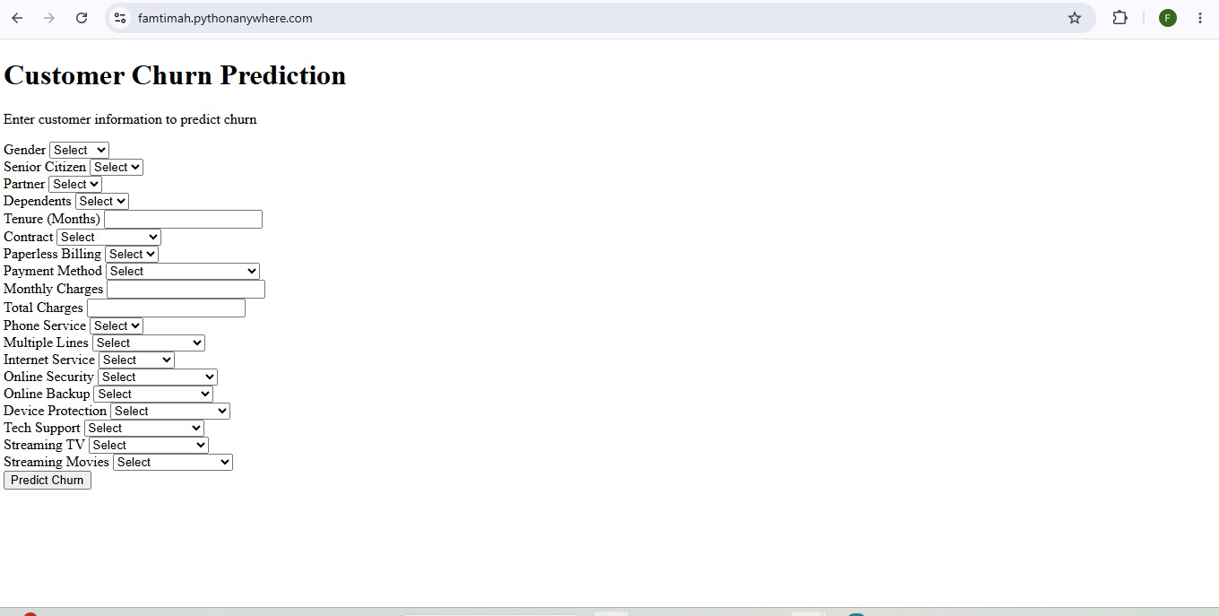

Figure 1: Customer Churn Prediction Web Application

20.2 Prediction Result
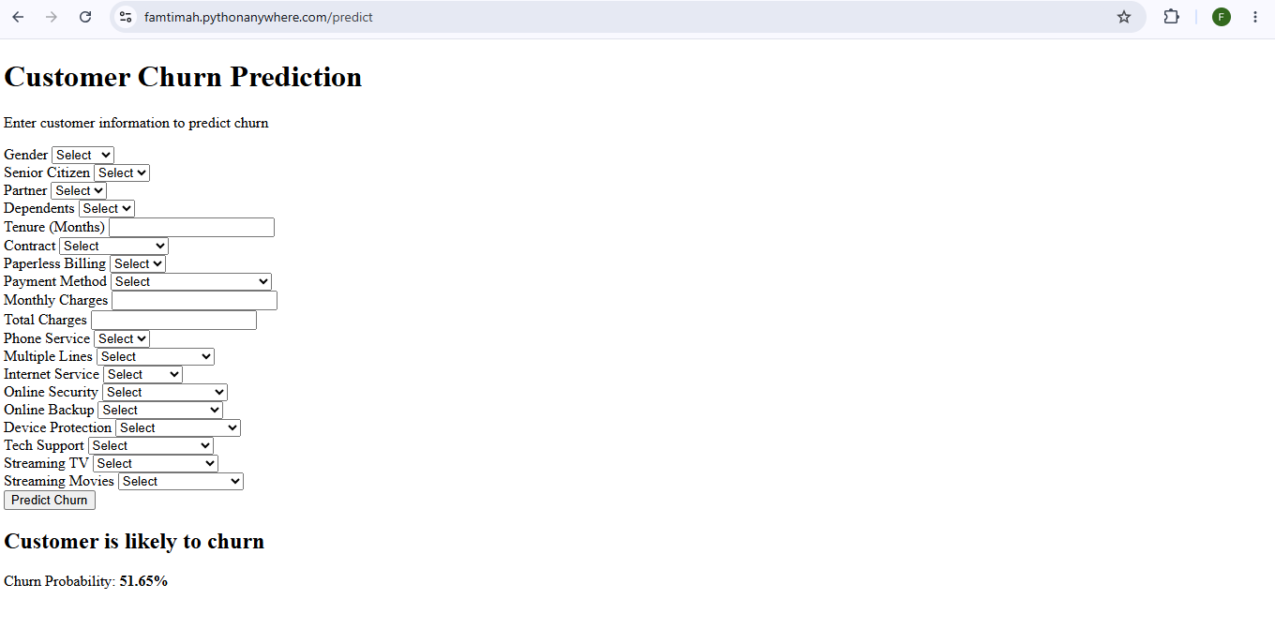
Figure 2: Customer Churn Prediction Result

20.3 Deployment
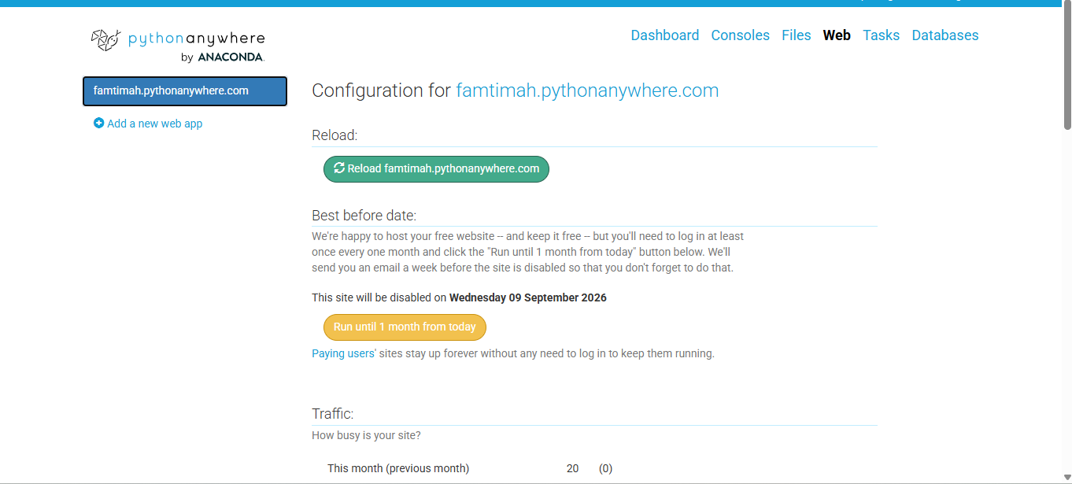Figure 3: PythonAnywhere Deployment

21. Results
The final system successfully achieved the project’s minimum target accuracy.
The model achieved:
80.27% Accuracy
The Flask application successfully connected the trained model and preprocessing pipeline to a web interface.
The system can:
- Accept customer information.
- Process the input.
- Predict customer churn.
- Calculate churn probability.
- Display the prediction through a web browser.
- Operate as an online deployed application.

22. Limitations
Although the system successfully performs customer churn prediction, some limitations remain.
The main limitations include:
- The model does not identify all actual churners.
- Recall is relatively lower than accuracy.
- Some actual churners are classified as non-churners.
- Model performance depends on the quality and representativeness of the dataset.
- The deployed application is intended for demonstration and academic purposes.
- The free PythonAnywhere deployment requires periodic account activity.

23. Future Improvements
Future improvements could include:
- Improving churn recall.
- Hyperparameter tuning.
- Testing additional machine learning algorithms.
- Using more customer behavioral features.
- Collecting more recent customer data.
- Improving the web interface.
- Adding interactive visualizations.
- Adding database connectivity.
- Adding automated model monitoring.
- Retraining the model periodically with new data.

24. Conclusion
This project successfully developed a complete Customer Churn Prediction System using machine learning.
The project covered the major stages of a data science workflow, including data analysis, SQL analysis, exploratory data analysis, feature engineering, preprocessing, machine learning, evaluation, explainability, web application development, and deployment.
The final model achieved an accuracy of 80.27%, meeting the project’s target of at least 80% accuracy. The model achieved a precision of 66.55%, recall of 51.60%, and F1 score of 58.13%.
A Flask web application was developed and successfully deployed on PythonAnywhere. The application allows users to enter customer information and receive a churn prediction and probability.
Overall, the project demonstrates how machine learning can be integrated with a web application to create a practical customer churn prediction system.

25. References
The project was developed using documentation and learning resources related to:
- Python
- Pandas
- NumPy
- Scikit-learn
- Flask
- Joblib
- SQL
- SHAP
- PythonAnywhere

26. Project Structure
The final project structure is:
customer_churn_project/
│
├── app.py
├── churn_model.pkl
├── preprocessor.pkl
├── requirements.txt
├── README.md
│
├── screenshots/
│ ├── 01_web_app.png
│ ├── 02_prediction.png
│ └── 03_deployment.png
│
└── templates/
└── index.html
Live Application:
https://famtimah.pythonanywhere.com/
Project: Customer Churn Prediction System
Author: Fatimah Ramzan

